# People Management System

Necessary Installation

* Python 3
* Flask (Micro kernel for web development)
* wtforms
* Sqlite3

Steps to follow for installing them

* Pip install flask
* Pip install wtforms
* Pip install sqlite3

To run the app

Python app.py in working directory of the project i.e

There is database file pms.db which contains few rows of users and admin I.e( human resource executive) for quick trials.

The first page to open up is login page for user authentication. There is separate functionality for HR and employees.

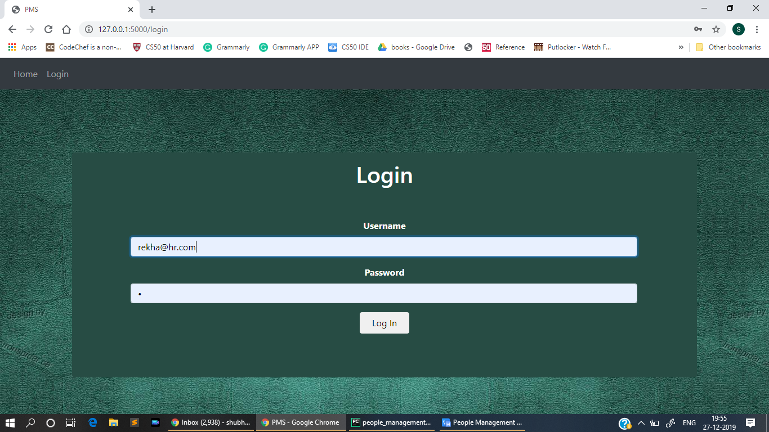

For login email and password is required

Sample login and password for HR ( Admin)

Email : [rekha@hr.com](mailto:rekha@hr.com)

Password: qwerty

Sample login and password for employee

Email: [ak@gmail.com](mailto:ak@gmail.com)

Password: qwer

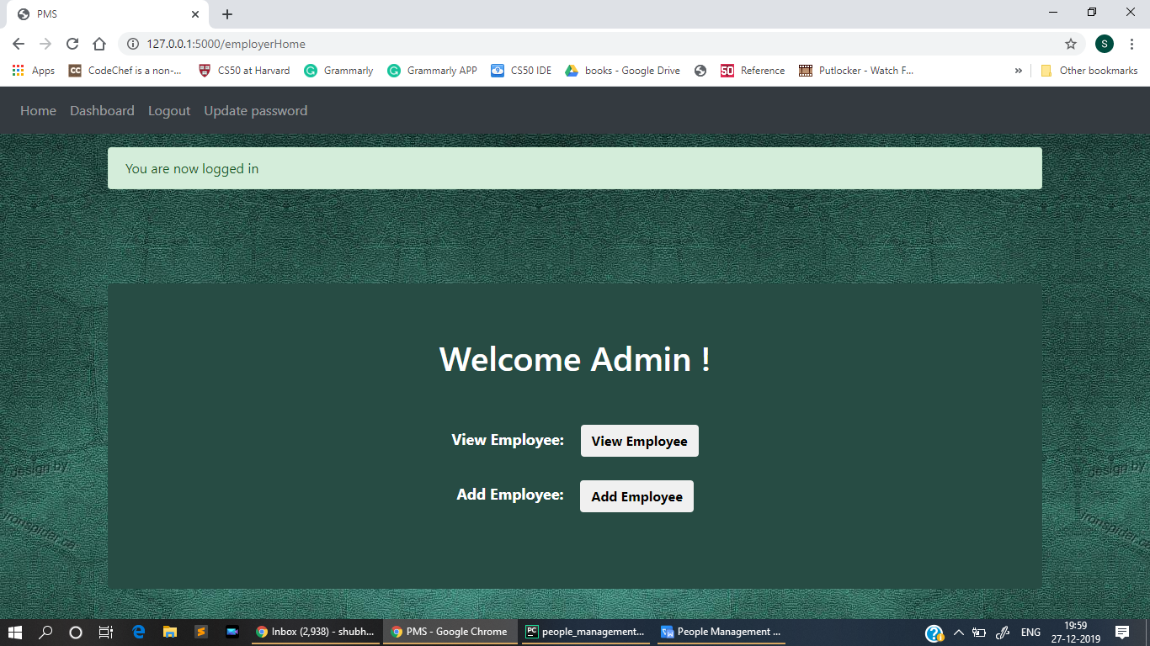

Welcome screen for Admins

In this screen Admins can view Employees and add employees. This step is used to create the user so that the user can view all their details. Only Admins I.e HR members can create and delete user from the system. Backend is relational database model which uses sqlite3 as its engine. The table diagram is given below.

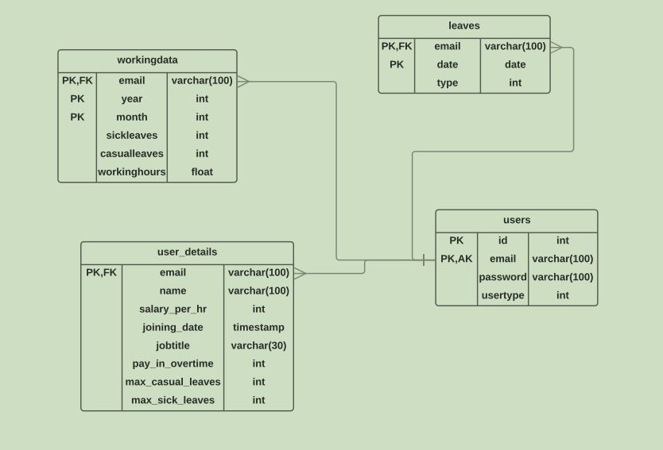

Database Schema

Moving along for Admins

1. Employee Details: Gives initial information of all employees
2. Add Employee: Add new employee in the system

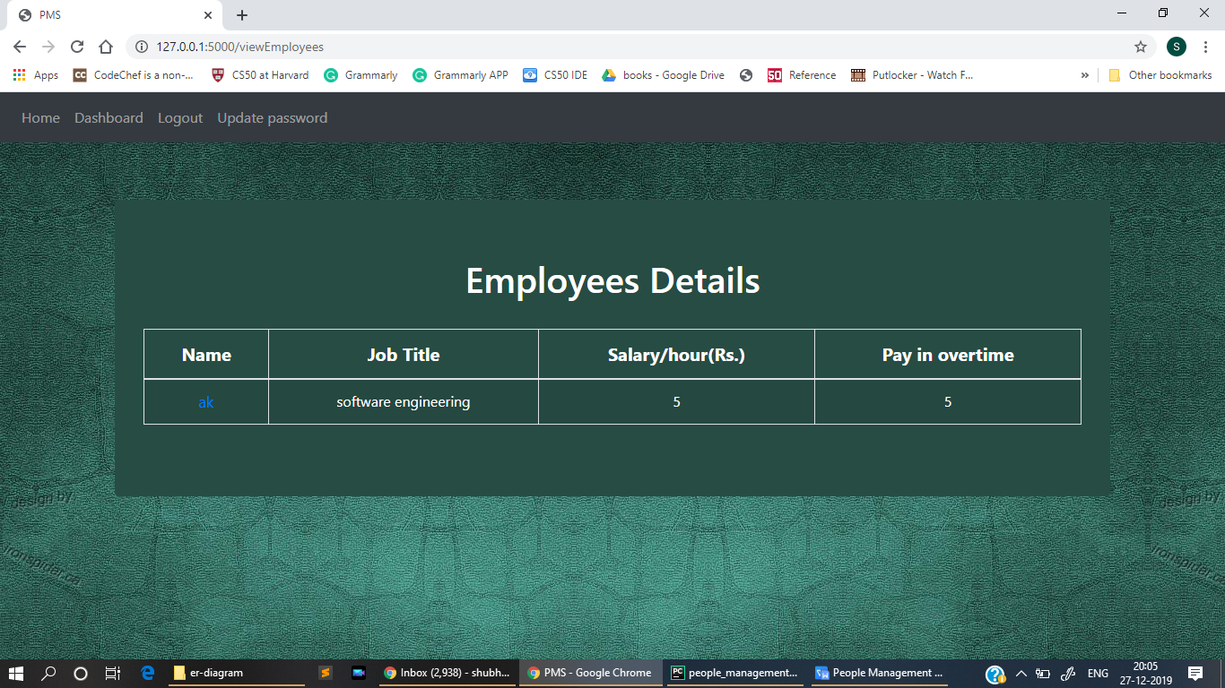

Employee Details page

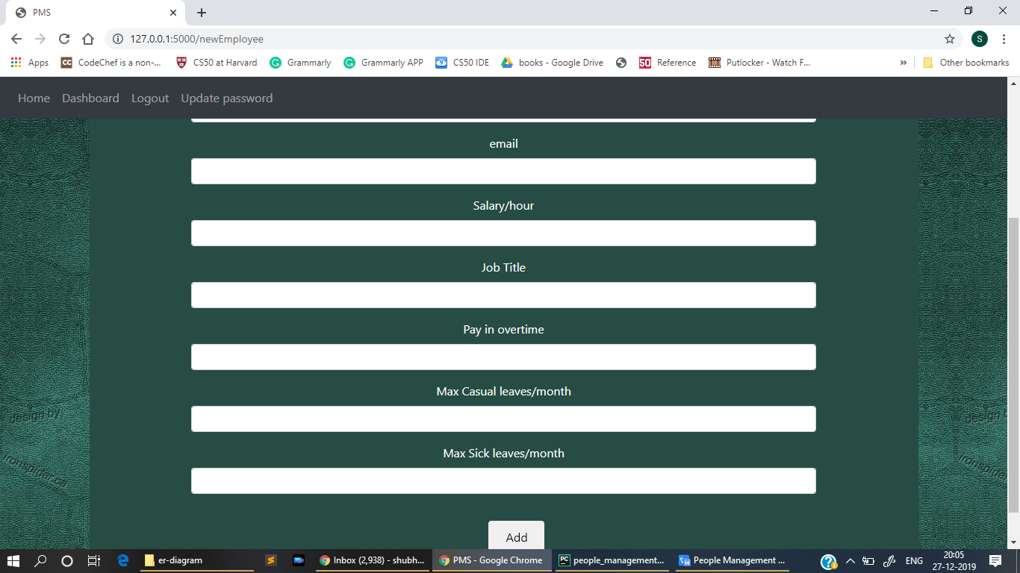

Adding a new employee into the system

**Now for Employee functionality**

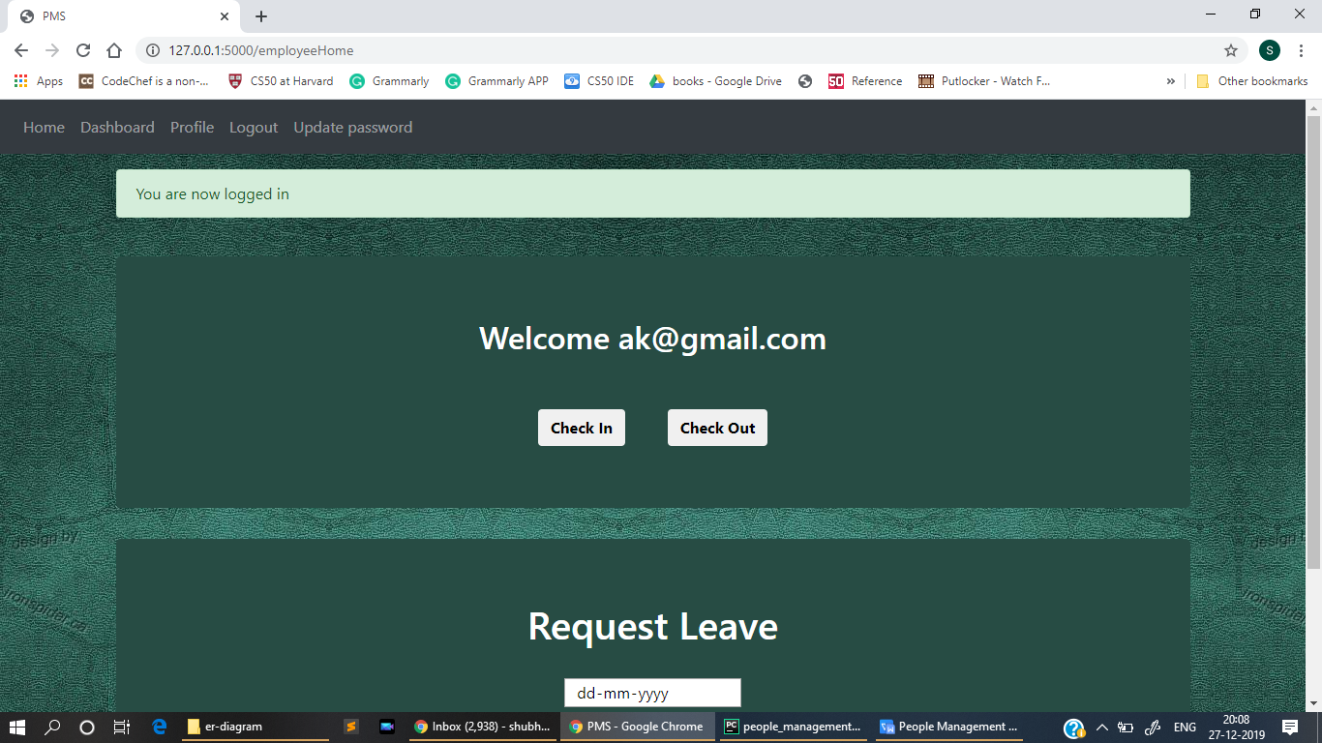

Employee Home screen

On this screen user can check in after first coming to the office and then check out when he/she is leaving that day’s of work. The working hour of the employee is stored in database for person’s review and salary.

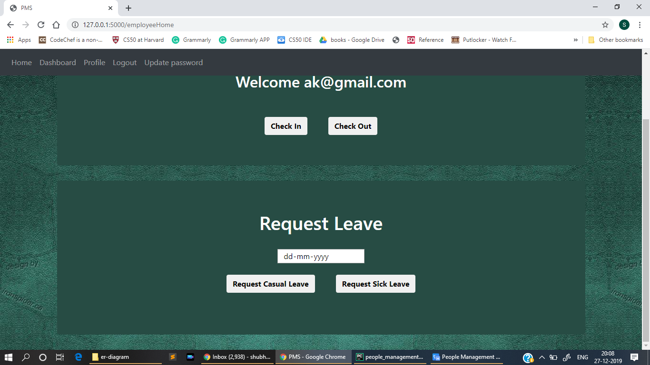

Request Leave functionality

This functionality allows the user to request for leave. Two kind of leave is allowed here Casual leave and sick leave. Everything is logged in the database which check for constraints

The constraints are:

* Should not exceed max limit of leave
* Should not on leave on that date already

The navigation bar allows to move between functionality with ease. Profile section provides all the information to the user about there employment such as number of leaves already requested and salary given to him and all benefits he/she is receiving from the company.

Few additional features worth mentioning

* There is reset password feature as default password is given to employees by HR(admins)
* Logout feature
* User remains Logged In
* Form Validation feature

Thank you

Shubham Raj

Final year Undergraduate

IIT(ISM) Dhanbad